**Displaying a specific range of lines from a text file using cat, sed and awk commands.**

**1. Using cat:**

* To display lines 10 to 20:

**cat filename | head -n 20 | tail -n 11**

This pipes the file's content to **head** to get the first 20 lines, then pipes those lines to **tail** to get the last 11 (lines 10 to 20).

Output:

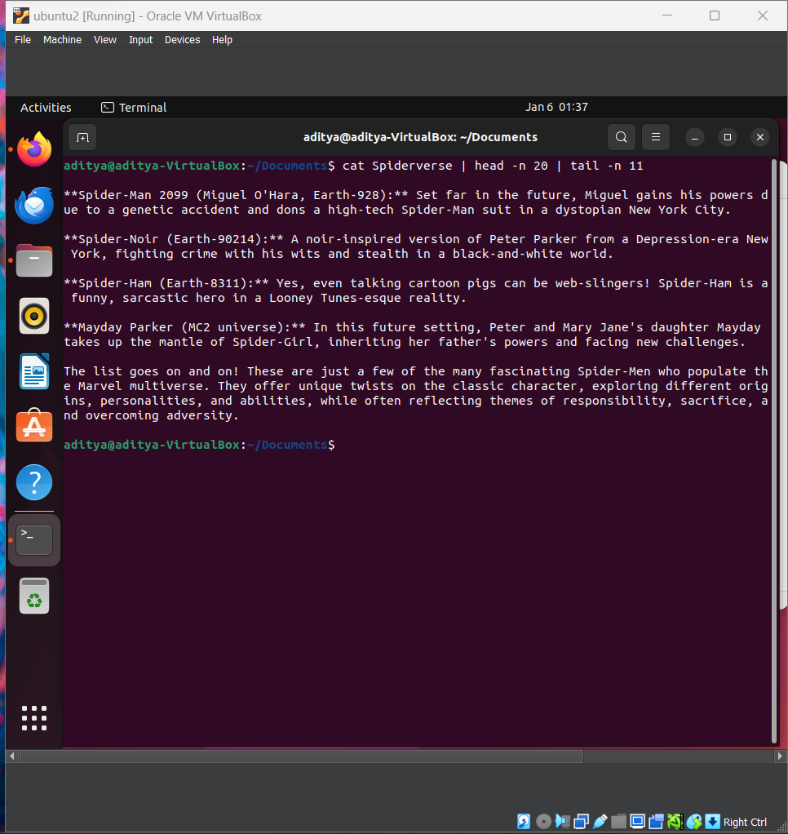

**2. Using sed:**

* To display lines 4 to 12:

**sed -n ‘4,12p’ filename**

The **-n** option suppresses automatic printing, and the **4,12p** command prints lines 4 to 12.

Output:

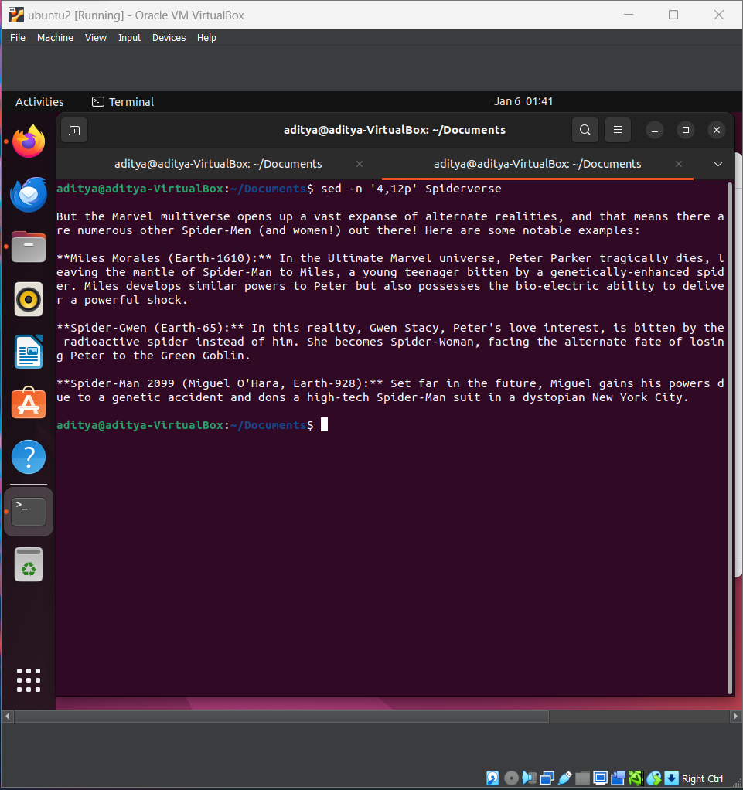

**3. Using awk:**

* To display lines 5 to 8:

**awk 'NR >= 5 && NR <= 8' filename**

The **NR** variable represents the current line number, and the condition selects lines 5 to 8.

Output:

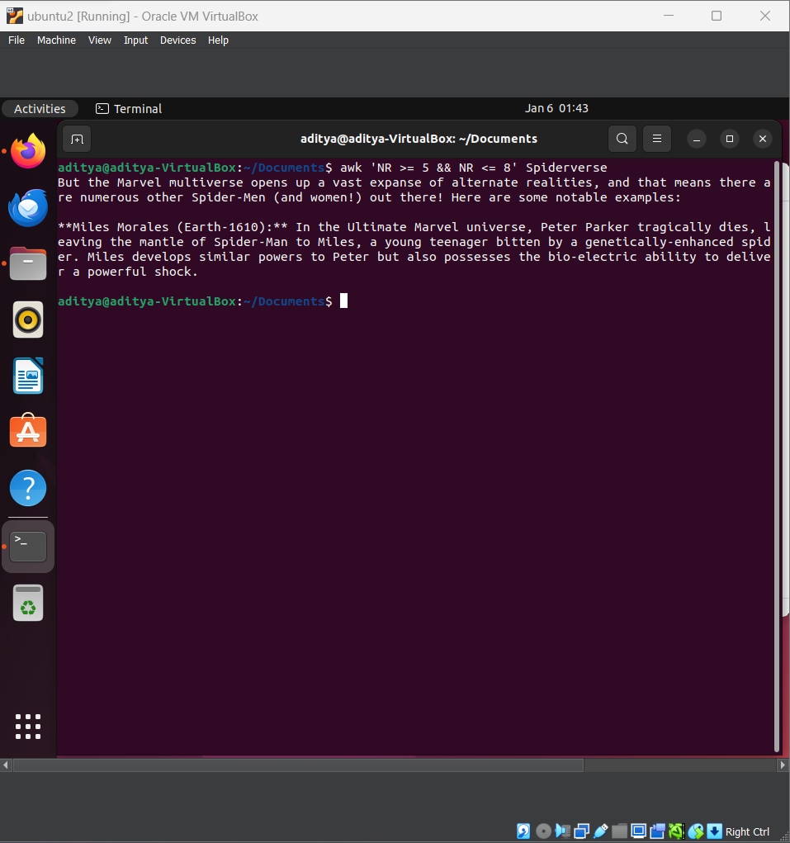

**Key points:**

* Line numbering starts from 1.
* The range includes both the starting and ending lines.
* For large files, using **sed** or **awk** is generally more efficient than **cat** with **head** and **tail**.